MRT Assignment

Real-Time Edge Detection using ROS & OpenCV

Saumya Dharmesh Shah

22B1238

Electrical Engineering, IIT Bombay

**Summary:**

In this task, I learned how to use ROS and OpenCV to develop a Python publisher node and a Python subscriber node for image processing. Also, I learnt how to convert between ROS and OpenCV picture formats using the cv_bridge library.

The publisher node publishes the frames it has captured from the default camera to the topic ‘frames’. The subscriber node processes each frame by applying Gaussian blur(using cv2.GaussianBlur()) and Canny edge detection(using cv2.Canny()) while subscribing to the 'frames' topic. A single window is then used to show both the original and edge pictures that were produced.

To test my implementation, I created a launch file that will launch the publisher and subscriber simultaneously; then, I ran the roslaunch command. I also used the rqt_graph command to visualize the communication between nodes and topics.

**Workflow:**

I begin with opening the terminal, there I run roslaunch mrt_assignment edge_detect.launch, which executes the launch file ‘edge_detect.launch’, which in turn launches the publisher.py and subscriber.py files which initialises publisher and subscriber nodes which communicate on a topic ‘frames’.

In the program, cv_bridge converts ROS message to OpenCV message and vice-versa.

I faced many bugs during the execution of my program.

* I was using just the name of the video instead of the whole path, so it was showing a black screen in the window
* My subscriber wasn’t working correctly, which was because I hadn’t used the cv2.waitKey() function in my processer
* I was getting an error in the np.hstack line of my subscriber code, which was due to the edge_img being grayscale which is a 2D array, but the original image was a 3D array, so I used cv2.cvtColor(edge_img,cv2.COLOR_GRAY2BGR) which converts the image from grayscale to BGR(i.e. from 2D to 3D array)
* I kept on forgetting to add dependencies to my package mrt_assignment. After surfing the internet for a few hours, I returned to the ROS Tutorials, where I realised I had to change the CMakeLists.txt and package.xml files.

**Output images:**

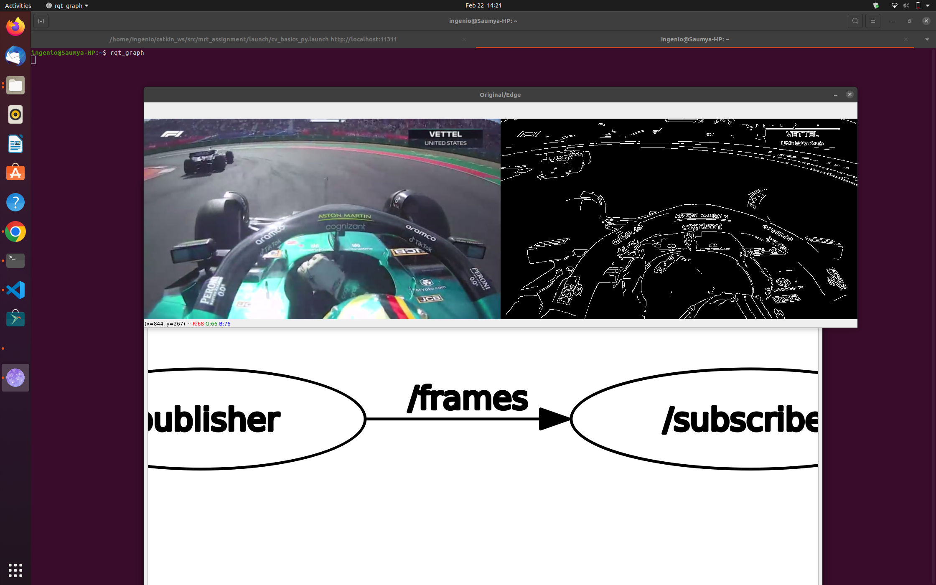

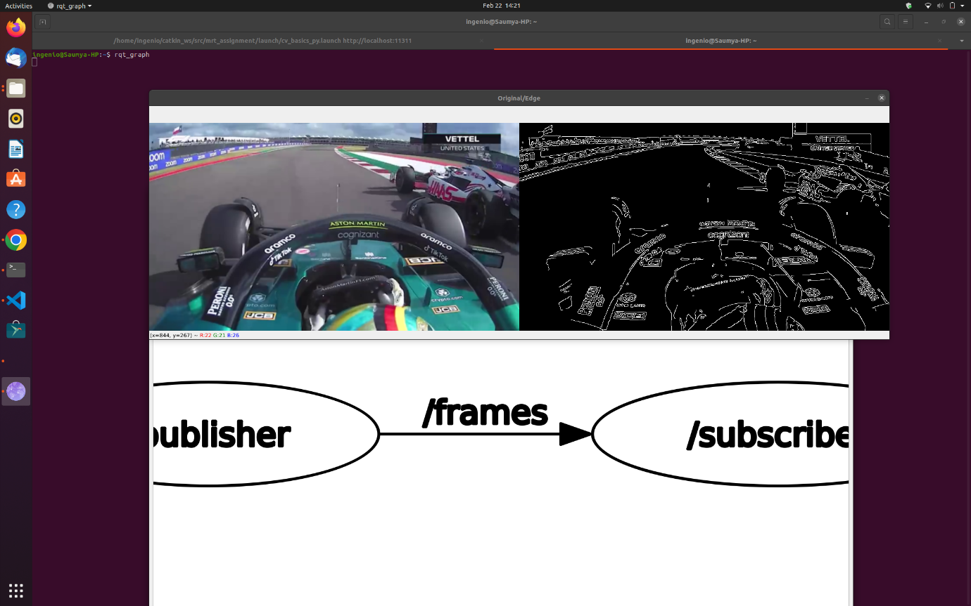

**rqt_graph image:**

(Two nodes *publisher* & *subscriber* communicating through the topic *frames*)

